Uniform Distribution Homework

- Suppose the time it takes a nine-year old to eat a donut is between 0.5 and 4 minutes, inclusive. Let X = the time, in minutes, it takes a nine-year old child to eat a donut.
  - Find the probability that a randomly selected nine-year old child eats a donut in at least two minutes.
  - Find the probability that a different nine-year old child eats a donut in more than two minutes given that the child has already been eating the donut for more than 1.5 minutes.
- Use the following information to answer the questions. The data that follow are the square footage (in 1,000 feet squared) of 28 homes.
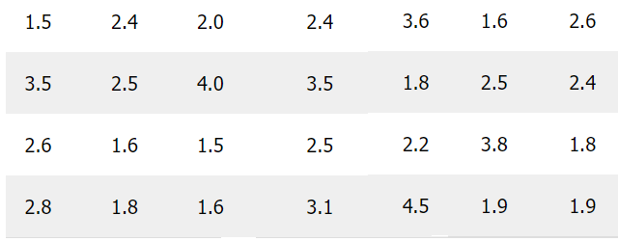
  - What type of distribution is this?
  - Write down the pdf.
  - What is P(2<x<3)?
  - What is P(x<3.5|x<4)?
  - What is the 90th percentile of square footage for homes?
  - Find P(x>9).
- The age of cars in the staff parking lot of a suburban college is uniformly distributed from six months (0.5 years) to 9.5 years.
  - Write the probability density function.
  - Find the average age of the cars in the lot.
  - Find the probability that a randomly chosen car in the lot was less than four years old.
  - Considering only the cars less than 7.5 years old, find the probability that a randomly chosen car in the lot was less than four years old.
  - Find the third quartile of ages of cars in the lot.

- The thickness x of a protective coating applied to a conductor designed to work in corrosive conditions follows a uniform distribution over the interval [20, 40] microns. Find the mean, standard deviation and cumulative distribution function of the thickness of the protective coating. Find also the probability that the coating is less than 35 microns thick.
- The commute time to work for a particular employee follows a continuous uniform distribution with a minimum time of 10 minutes and maximum time of 22 minutes.
  - Write down f(x).
  - What is the probability that the employee’s next commute to work will require more than 14.5 minutes?
  - What is the probability that the employee’s next commute to work will require between 11 and 20 minutes?
  - What commute time represents the 40th percentile of this distribution?

